**Sage**

**SAGE X3 PEOPLE LEAVE REPORTS**

**Technical Design Document**

**PR01 – ZLVAOD – Approved Outstanding leave days – UBA - NIGERIA**

Prepared by Mauritz Pieterse

# Change Record

|  |  |  |  |  |
| --- | --- | --- | --- | --- |
| Date | Author | Version | Change Reference | Naming Convention |
| 22/11/2017 | Alma Kaltwasser | 1.1 | Initial document |  |
|  |  |  |  |  |
|  |  |  |  |  |

# Distribution list

|  |  |  |  |  |
| --- | --- | --- | --- | --- |
| Name | Designated Business Area | Responsibility | Date | Method of Distribution |
|  |  |  |  |  |
|  |  |  |  |  |
|  |  |  |  |  |

# Naming Convention and Definitions

|  |  |
| --- | --- |
| Naming Convention | Definition |
|  |  |
|  |  |
|  |  |

**Contents**

A. Change Record 2

B. Distribution list 2

C. Naming Convention and Definitions 2

1 Executive Summary 4

2 Sample 5

3 Header 7

4 Columns 8

5 Grouping 9

6 Footer 9

7 Output 10

8 Selection 10

9 Totals 10

10 Restrictions 10

# Executive Summary

This technical design specification document is intended to describe the technical details that will be created for the Sage X3 People project for the report highlighted on the introduction page of this document.

In this document we address the intended fields that will be included on the report, as well as explanations for the elements implemented where applicable, restrictions to the report, possible clarification areas which will be documented on a new version of this document and suggestions to accommodate best practise which will by default be included to the TDD and can be removed if the suggestion is not accepted.

The areas covered in this document include:

ZLVAOD

( PR02_ZLVAOD_Approved_Outstanding_leave_days_UBA_NIGERIA.docx)

# Sample

The below sample is the expected result as provided by the client**.**



# Header

APPROVED OUTSTANDING LEAVE DAYS REPORT.

Text/Data box 1 - APPROVED OUSTANDING LEAVE DAYS

# Columns

**EMPLOYEENUMBER**

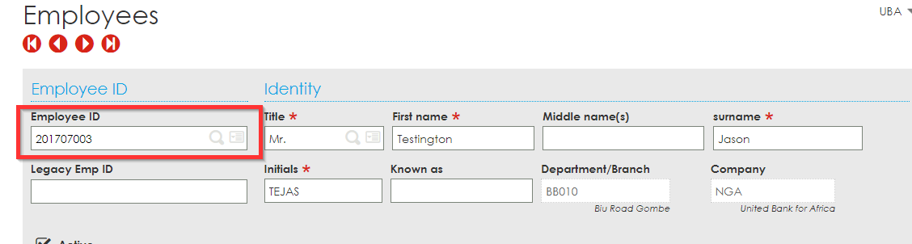

**EMPNAME –** Will be a concatenation of the below two fields, separated with a space.

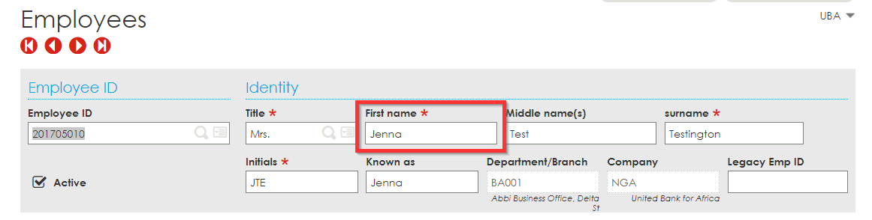

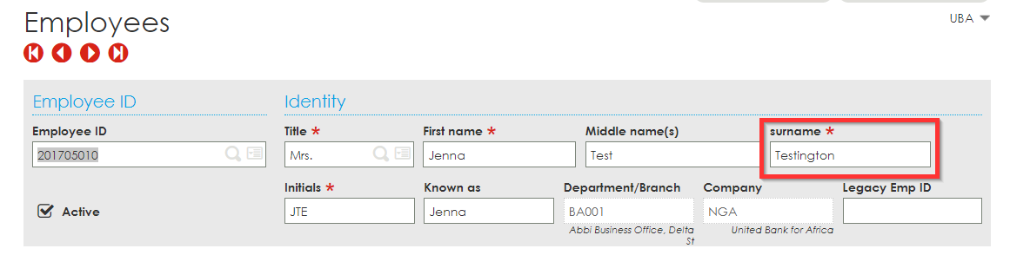

**ROLE**

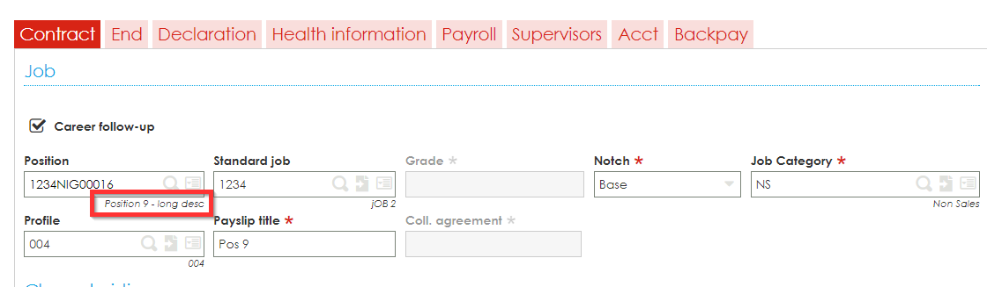

**GRADE**

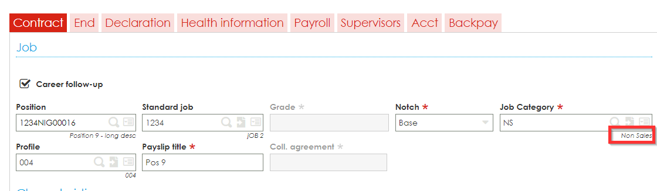

**LEAVECATEGORY**

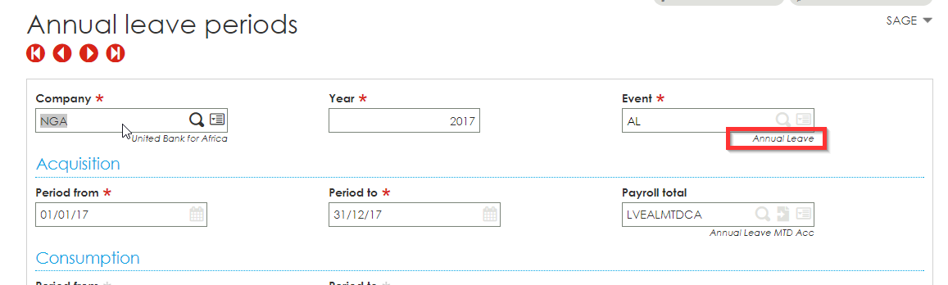

**DAYSENTITLED**

**Clarity as to whether this will be recorded within sage is required. If this is the case, communication regarding the recording of the latter value needs to be communicated to Sage so it can be documented. E.g will this be recorded on a total/heading/variable and what will the name of the total/heading/variable be?**

**LASTAPPROVEDYEARFOROUTSTANDINGDAYS**

**APPROVEDOUTSTANDINGDAYS**

# Grouping

# Footer

# Output

This report will be executed as a crystal report. The report output can be found by going to the following location within sage.

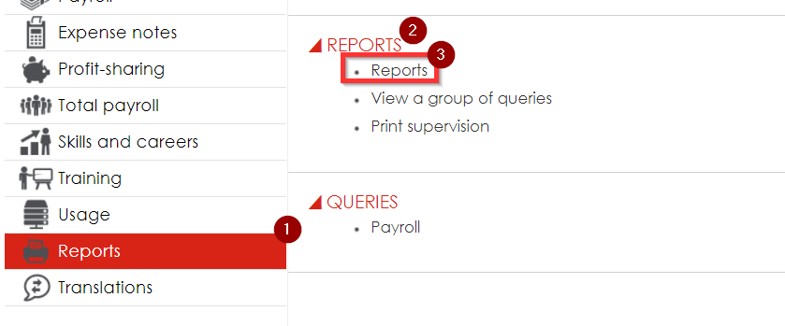

# Selection

The client will have to specify values for the following parameters:

# Totals

# Restrictions

None